

Vaping Policy
2024-25

Signed: Jay Treacy
Date Reviewed/ Updated: 02/09/2024

1. Purpose and Scope
- Objective: To promote a healthy and safe learning environment by prohibiting the use of vaping devices on U-Neek learning premises.
- Scope: Applies to all students, staff, and visitors on U-Neek property, during school-sponsored activities, and in school vehicles, and off site activities.

2. Definitions
- Vaping Devices: Electronic devices that simulate smoking, including e-cigarettes, vape pens, and any other devices that produce vapor or aerosol from a liquid or other substance.
- School Property: Includes all buildings, grounds, vehicles, and facilities owned, leased, or used by the U-Neek Learning.

3. Prohibition
- Student Use: Students are prohibited from using, possessing, selling, or distributing vaping devices on U-Neek Learning property, during school-sponsored events, or while traveling to and from school.
- Staff and Visitor Use: Staff and visitors are also prohibited from using vaping devices on U-Neek Learning property.

4. Consequences for Violation
- Students:
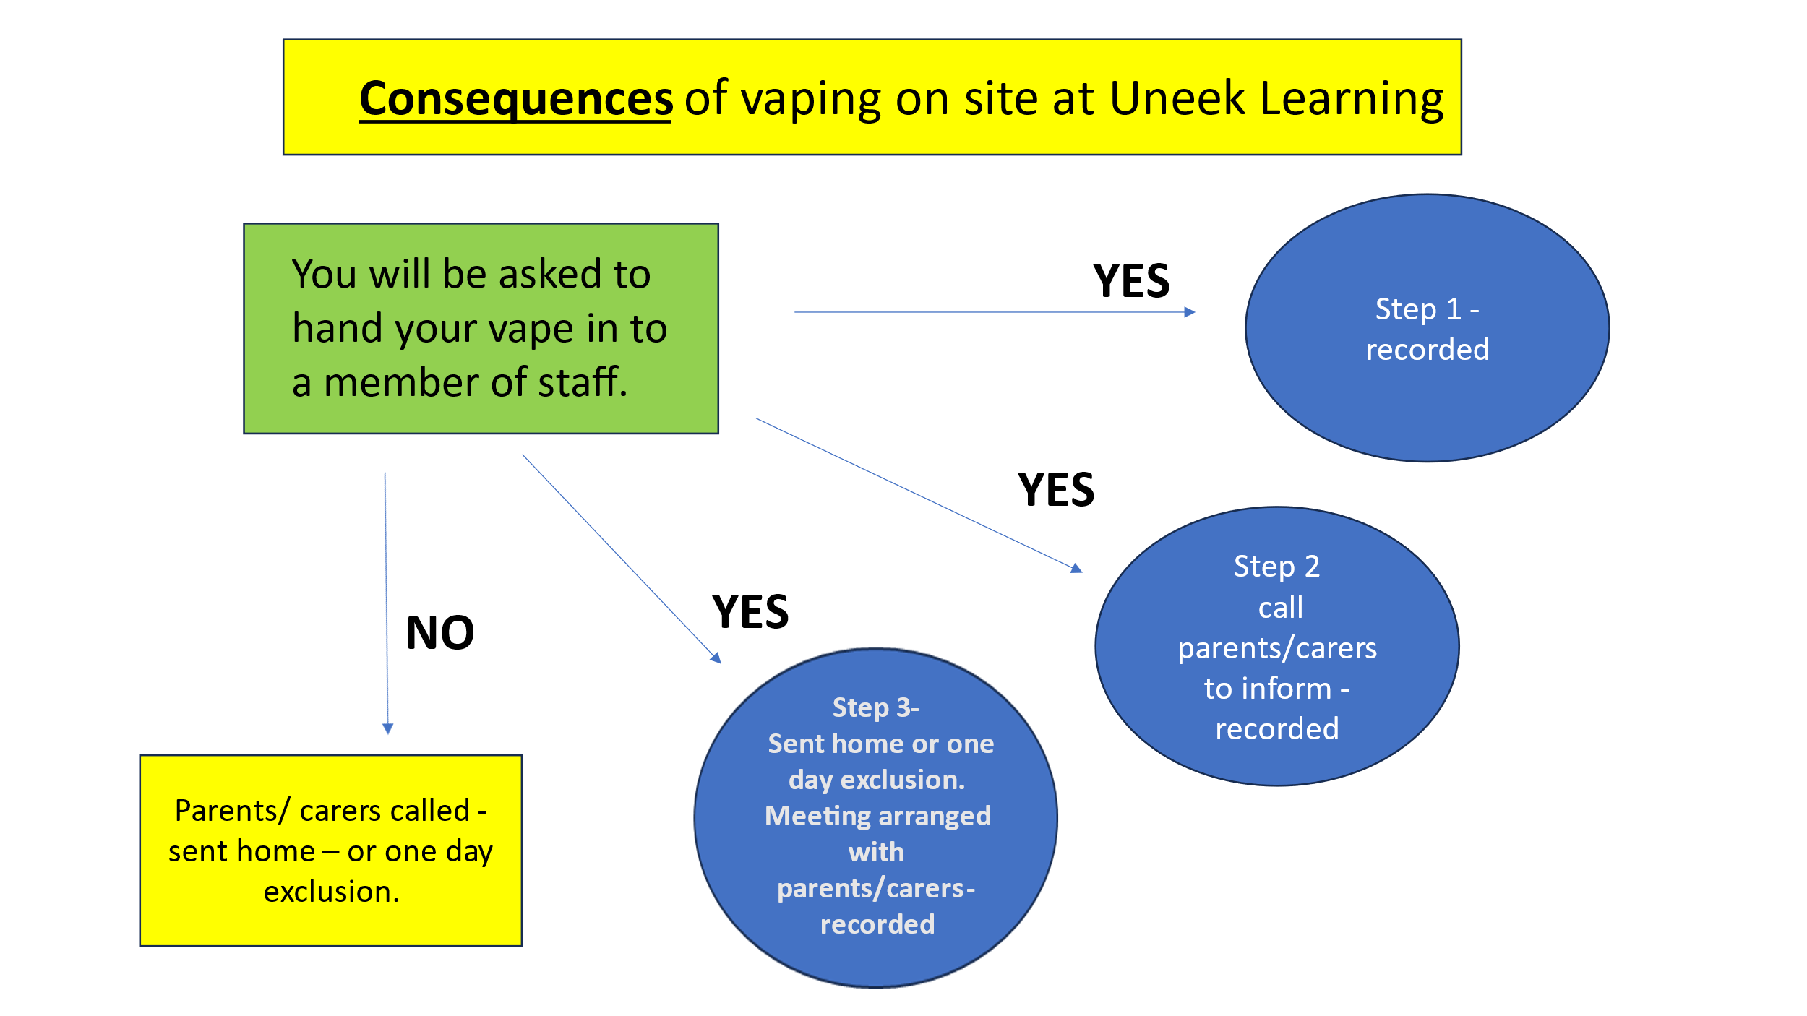
- Staff: Disciplinary action consistent with U-Neek Learning employment policies.
- Visitors: May be asked to leave U-Neek Learning property.

5. Education and Prevention
- Curriculum Integration: Incorporate information on the risks of vaping into health education courses, PSHE lessons, posters and information around the building.

6. Storage of Devices
- Procedure: Devices will be securely stored into individual zip up wallets (within the staffroom) and may be returned to the student when leaning school to go home, with parental request.

7. Parental Involvement
- Notification: Parents/Carers will be notified of all violations and involved in a meeting and behaviour sanction process. All parents/carers will be emailed, phoned and advised on the student induction/ initial visit about the vaping policy and procedure.
8. Review and Evaluation
- Annual Review: The policy will be reviewed annually to ensure its effectiveness and relevance.

9. Legal Compliance
- State and Local Laws: Ensure the policy is in compliance with state and local regulations regarding tobacco and vaping products. No-one under the age of 18 should have a vape.

10. Communication
- Dissemination: The policy will be communicated to students, staff, and parents through emails and phone calls. Information posters are around all areas of the building to Uneek Learning to inform students that we are a Smoke/Vape free Centre.

11. Support Services
- Access to Help: All students access the PSHE curriculum to support education around the risks of vaping. Students also have access to U-Neek Learning pastoral programmes led by experienced and supportive staff. Uneek Learning work with local external support agencies to offer specialist advice and guidance around smoking and vaping cessation.

